31 July 2026

Meta
Facebook
River Cities Rotary,
https://www.facebook.com/RiverCitiesRotary/

Re: Authorization to Use Rotary International’s Trademarks

To Whom it May Concern:

Rotary International owns, maintains, and protects certain trademarks worldwide on behalf of its member clubs, including Rotary Clubs and Rotaract Clubs. Rotary International’s trademarks include, ROTARY, ROTARY CLUB, ROTARIAN, ROTARACT, ROTARACT CLUB, INTERACT, INTERACT CLUB, END POLIO NOW, PEOPLE OF ACTION, SERVICE ABOVE SELF,
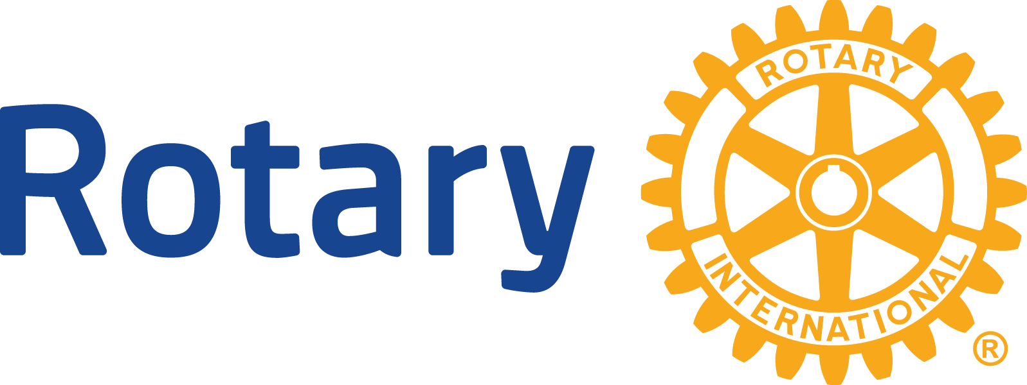, 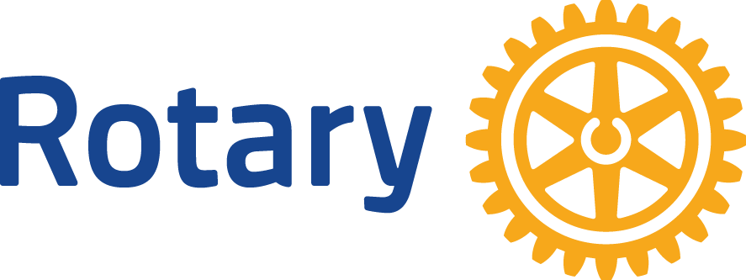,  , among others.

Rotary International charters Rotary clubs and Rotaract clubs as members of the worldwide association of member Rotary and Rotaract Clubs. Rotary and Rotaract clubs are afforded certain privileges as part of their membership in Rotary International, including the right to use the ROTARY CLUB trademark in its club name, and Rotary’s gearwheel logos in its club logo. A club can use these Rotary International trademarks for club business, including on social media.

The River Cities Rotary Club, District 6420, Zone 29 is a chartered member of Rotary International, with the aforementioned privileges.

Sincerely,
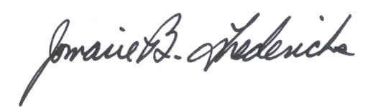
Jomarie B. Fredericks
Deputy General Counsel
Chief Intellectual Property and Brand Counsel

